WHO ARE WE?

Isolomzi Electrical CC is a black owned company that provides valuable electrical installation services, electrical repairs and maintenance and other electrical services to various clientele including government, airports authorities, private airports, property developers, private companies and individuals. The business is therefore an effort that seeks to address poverty through entrepreneurship and to transfer technical skills to the youth.

The company was formed as a direct response to:

- The government’s call to involve blacks in the mainstream of the economy in order to redress the economic imbalances of the past,
- To take advantage of opportunities created by the government’s programs such as the Expanded Works Programme, the urban renewal programme and other infrastructural installation programme.

OUR VISION

Isolomzi Electrical is a small company with big dreams and aspire to be South Africa’s leading black-owned electrical contractor.

OUR MISSION

To achieve the above stated vision, the company is guided by the following mission:
  - To make safety a top priority
  - To provide work to the previously disadvantaged individuals and empower them through transfer of skills from our technical personnel
  - We are strongly committed to deliver to our clients a quality service comparable to none.
  - We commit ourselves to the development of communities within which we operate

BUSINESS PRINCIPLES

The member of Isolomzi Electricals has developed a guiding philosophy that is reflected by the following principles:

  - Participative management style.
  - Skills up-liftment and development.
  - Transparency and integrity in business dealings.
  - Adherence to good corporate governance.
  - Adherence to acceptable and best industry standards.
  - To promote the culture of occupational health and safety in the work place

OBJECTIVES

The specific objectives of the company are:

  - To establish a successful profitable business company whereby jobs are created for families and community.
  - To utilize available diverse qualifications, skills, knowledge, work experiences, of owners of the company and staff.
  - To establish a brand name in the provision of superior electrical solutions and allied services.
  - Increase the company’s capacity in order to handle bigger projects.
  - To supply and install electronic security system.

SERVICES OFFERED

Our services are wide-ranging and cover the following:

- Electrical installation in Industrial, Domestic and in Commercial Areas
- Certified to work in Hazardous Areas such in Petrol Station, Sewer Plants, Waste Water Treatment Plants.
- Supply and Installation of PV System (Solar Power System-Domestic)
- Electrical maintenance and repairs
- Calibration and Maintenance of PAPI Lights in Airports
- Install, repairs and maintenance of AGL in Airports
- Infrared Thermography: Inspections on:

- Substation & Switchgear
- Transformers
- Couplings
- Lubrication of Gears
- Drive Belts / Couplings- Electrical
- Switchgear
- Motor Control Centres
  - Electrical tests on Infrastructure Installations
  - Installations, Maintenance of electrical Panels (Single and Three Phase Supply)
  - Electrical fault diagnosis
  - Hazardous area classification
  - Hazardous area maintenance for Electrical Installations
  - Test and Issue Certificates of Compliance (CoCs) for Domestic, Commercial and Industrial Installation
  - Test and Issue Certificates of Compliance (CoCs) for Hazardous Installations, [explosive areas such as Petrol Stations, Hospital, Sewerage Plants, etc.
- Electrical Inspections/Audit and reporting with Infrared Thermography Tests.
- Installing and maintaining Alarm Systems
- Installation of Electric Fencing
- Issuance of Certificates of Compliance (CoCs) of Electric Fence
- Install gate automations and repairs
- Install garage automations and repairs
- Installations of CCTV and repairs [cameras]
- Installations of Access control Systems and repairs
- Installations of intercom systems and repairs
- Supply of all electrical material and equipment.

MANAGEMENT

ISOLOMZI ELECTRICAL CC is managed by three black individuals with extensive knowledge and skills in various spheres see below:

1. Hugh Mojalefa Radebe, Managing Director:
- Qualified Electrician-Mining (MIETTB)
- Qualified Installation Electrician (IE)
- Qualified Master Installation Electrician (MIE)
- National Electrical Diploma (Electrical Engineering)
- Electrical Trade Certificate, obtained from the mining sector (MIETTB)
- National Teachers’ Diploma-Electrical Engineering
- SHEMTRAC and OHS Act certificates.
- Airport Safety Management Systems (SMS)-IATA
- Airport Certification-FAA
- ITC Level 1 Infrared Thermography
- Management Development Programme (MDP-University of Pretoria)
- Programme in Engineering Management (PEM- University of Pretoria)

2. Albert Itumeleng Mabidikane, Managing Director: Technical Operations
- Qualified Electronic Technician
- N4 Electronic Engineering
- ESKOM MV/LV Line Construction
- ORHVS (Operational of High Voltage Systems)
- More than 10 years of experience in Electronic Security Industry
- Technical Manager of MKS Security Services
- Technician at ADT, Chubb Security Services
- Senior Technician at Top Securities

3. Johannes Lerato Sikwane, Managing Director: Human Resource Department and Marketing
- Qualified legal advisor, obtained B Juris in 1991,
- He has the much broader understanding of Labour relations and its operations in general,
- CCMA Commissioner to deal with Labour relations cases,
- Human Resource Management
- Marketing

TECHNICAL ASSISTANCE

Isolomzi Electrical has established a strong relationship with various electrical contractors and subcontractors, as part of its empowerment programme as well as to meet its skills shortage in key areas.

OUR KEY COMPETENCIES

- Strong technical and management skills
- Project management skills
- Complementary technical and other professional services expertise

- Wholly owned by historically disadvantaged.
- Affiliation to professional associations.

PROFESSIONAL MEMBERSHIP

Isolomzi Electrical is registered with the following bodies:

- Registered as Electrical Contractor with Department of Labour: GN 00485
- Construction Industry Development Board (CIDB)- Electrical Engineering Work-Building Reg. No.201161
- Electrical Contractor’s Association SA (ECA SA), Registration No: NP 0969

QUALITY CONTROL

We always endeavour to comply with existing industry and government regulations of our products and services. In particular, we will comply with the requirements of the Construction Industry Development Board and in future we intend to be a fully registered member of the National Home Builders Registration Council (NHBRC). We will also comply with other regulations governing the protection of the environment and the safety of employees and of clients.

LIST OF CLIENTS AND REFERENCES

Since its inception Isolomzi Electrical has completed a number of projects both for individuals and corporations. Some of the projects that the company has completed are listed below:

Clients | Nature of work done | Contact details for references
Cape Town International Airport | Calibration of PAPI Lights and Maintenance thereof | Mr Fulufhedzani Rathogwa  +27 72 106 6450
Orthofusion Investment (Pty) Ltd- OR Tambo International Airport; Cape Town International Airport; Braamfisher Airport; | -Calibration of PAPI Lights and Maintenance  - Maintenance of Aeronautical Ground Lights | Mr Samuel Mothothi (Orthofusion Pty Ltd)  +27 82 337 9945
Polokwane International Airport | Calibrating PAPI Lights  Maintenance on PAPI Lights | Mr Nkhangweni Netshipfepfe  +27 82 493 8663
Vereeniging Airport | Calibration of PAPI Lights and Maintenance of AGL | Mr Colin Mokoena  +27 71 680 8783
Pilanesberg International Airport | Calibrating PAPI Lights and Maintenance of AGL | Mr Matshele  +27 73 324 7965
Buzaphi Construction Pty Ltd | -Installed CCTV; Remote Gate and Alarm System;  -Installing electrical systems in Northern Cape, 7 Clinics;  -Done electrical rehabilitation in the following waste water treatment plants:  Barkley West Waste Plant  Warrenton Waste Plant  Olifanshoek Waste Plant  Douglas Waste Water Plant. | Mr. Benedict Teffo  +27 82 561 4935
Moabi Funeral Parlour and Mortuary | Electrified installations for Moabi Mortuary  Installation of CCTV Cameras  Security Alarm System | Mr. Ofentse Moabi  Cell: +27 82 940 7123
Magaliesburg and Randjiesfontein Farms | Electrification of Farm House at Magaliesburg,  -Electrifying Butchery in Magaliesburg | Mr. Mxolisi Zwane  Cell: +27 82 895 5235
Apogees Contractors Pty Ltd | Audit, Test and Issuance of CoC on completion of remedial works on BP fuelling stations in Gauteng and North West Provinces | Mr Hillary Molotsi  +27 82 573 5847
Signedition Pty Ltd | Electrification of Signage for Total Filling Stations and Total Distribution Centre | Mr. Collin Mthombeni  +27 82 604 0210
PSA & Romano Signage | Electrification of Signage for Total Filling Stations and Total Distribution Centre | Ms Daleen Prinsloo  +27 82 822 7285

BENEFITS OF DOING BUSINESS WITH US

At Isolomzi Electrical, we realized that building or renovating home, offices, industries, is a life time investment and therefore the need to get it right the first time and cannot be overemphasized. By letting Isolomzi Electrical CC to handle your electrical work, repairs, maintenance, or fitting requirements you stand to benefit from the following:

- Customer service excellence which is comparable with the best
- A quality service that comes at an affordable price
- A proven history of successful delivery.
- Gain access to a management team with expertise, knowledge and experience.

 | 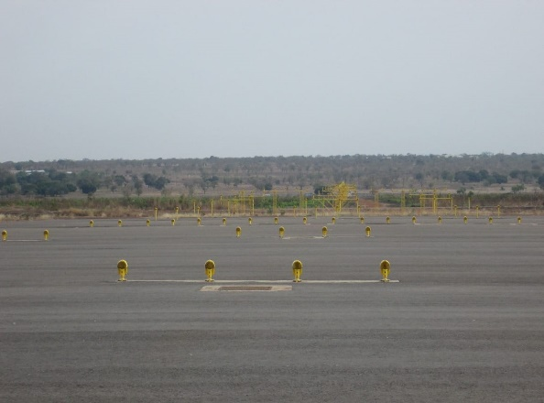
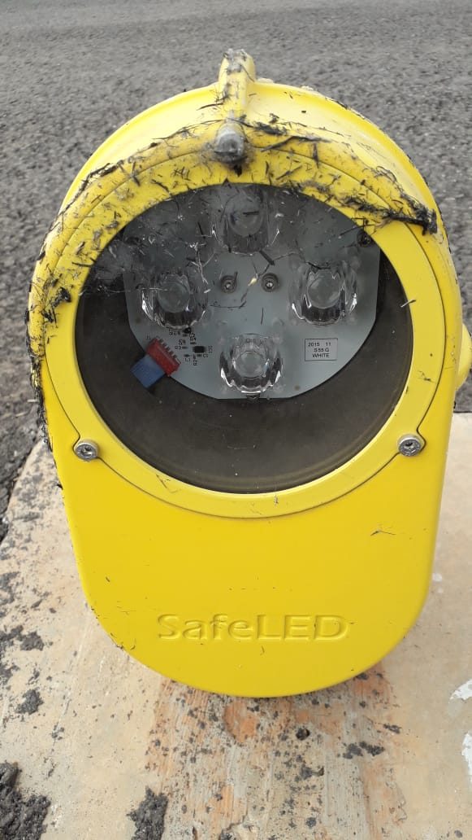 | 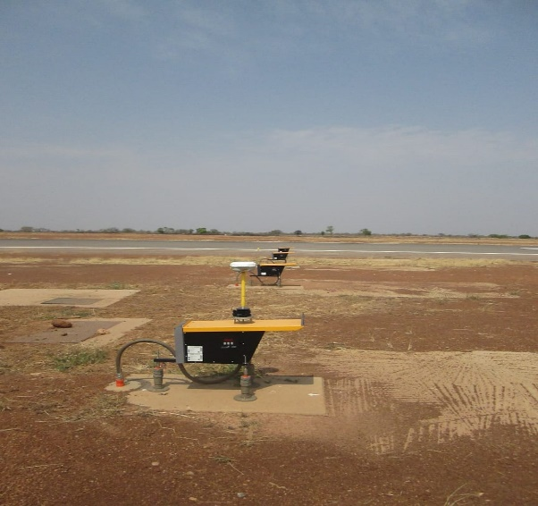
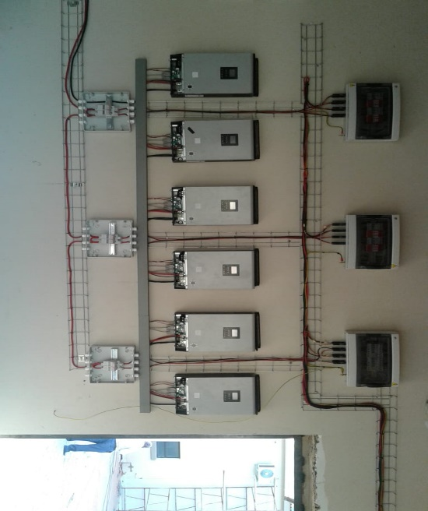 | 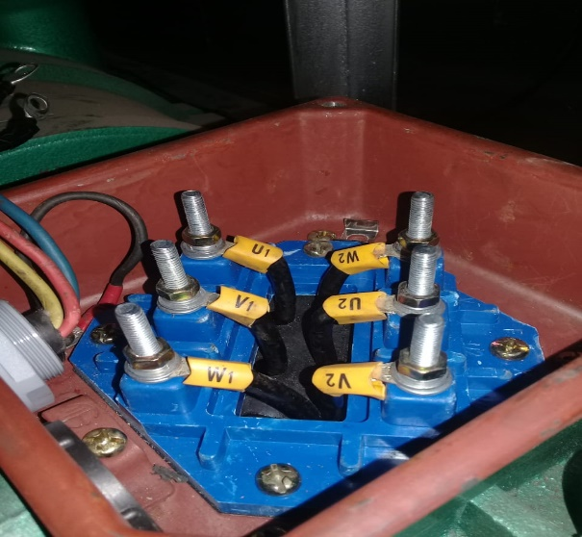
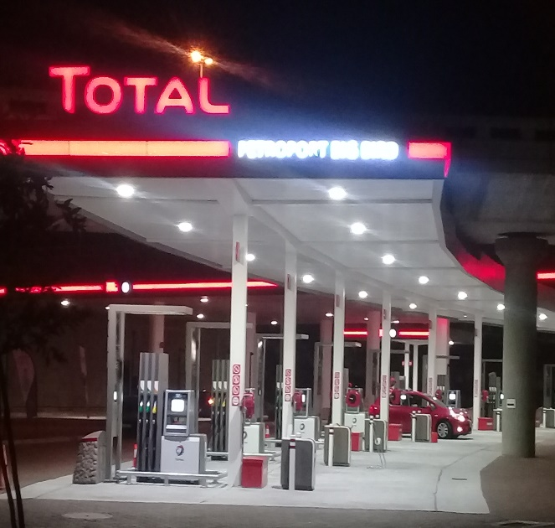 | 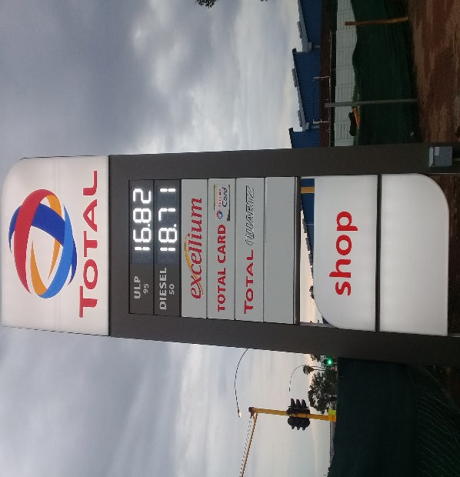

For a fast, efficient and professional service, please call us now.

Contact Details

ISOLOMZI ELECTRICAL CC, 2008/162720/27
e-mail: isolomzielectrical@webmail.co.za
Hugh Mojalefa Radebe;
Cell: +2783 466 2301
e-mail: hugh.radebe1967@gmail.com
Albert Mabidikane;
Cell: +2772 966 9502
e-mail: albert.mabidikane@gmail.com

